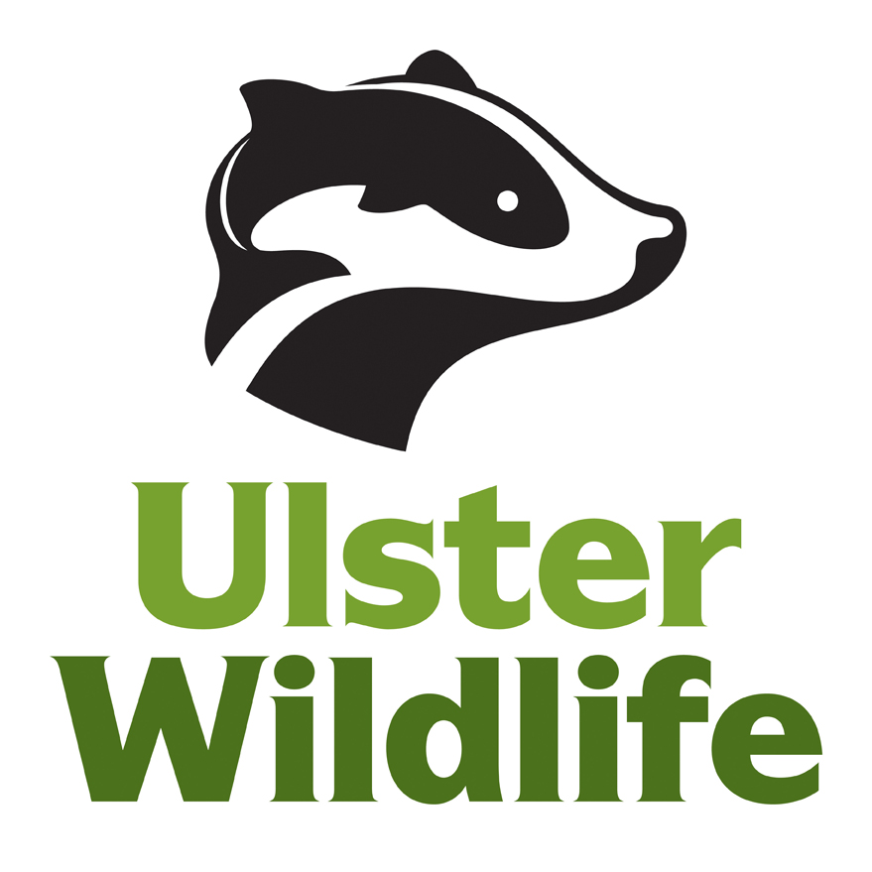
Ulster Wildlife - Trainee Agreement

Nature Skills NI Traineeship
(Ulster Wildlife is the operating name of Ulster Wildlife Trust, a charity registered with the Charity Commission for Northern Ireland NIC 101848. A company registered in Northern Ireland No. 12711)

This is the statement of the conditions and procedures of training and agreement between Ulster Wildlife (Ulster Wildlife) and _________________________.... (insert name of trainee)

1. Programme Details & Duration

You are agreeing to register as a trainee on the Nature Skills NI programme with Ulster Wildlife. Your training placement is for a fixed period of 12 consecutive months.

The start date of your training placement is: Monday 2nd March 2020
The completion date of your training placement is: Friday 26th February 2021

Probationary Period

The first month will constitute a probationary period. Ulster Wildlife reserves the right to extend this probationary period if it is deemed necessary. If at the end of the first month your training proves unsatisfactory to either to the Project Coordinator (PC), Ulster Wildlife or yourself, your place on the programme and the associated bursary payment will be withdrawn during or at the end of the probationary period. Successful completion of the probationary period will be confirmed in writing.

2. Training Bursary

Your bursary payment is at the rate of £13,261.25 / £7,956.75 per annum. 10% of the annual bursary will be held back (£1,326.17 / £795.63) and paid on completion of the 52 week placement and successful completion of the Lantra Accredited Training Programme. Your monthly bursary payment will therefore be £994.59 / £596.76 and is paid directly into your bank/building society account by BACS transfer monthly in arrears, at least three working days before the end of each month. You will need to provide us with your bank account details for payment.

NB: Ulster Wildlife Trust understands this bursary under current regulations to be considered an educational bursary and is therefore non-taxable. As you are not employees of Ulster Wildlife Trust you are responsible for your own relationship with HM Revenue & Customs.

3. Deductions

Ulster Wildlife has the right to deduct from your bursary any sums which you may owe Ulster Wildlife including, without limitation, any over-payments made to you by Ulster Wildlife or losses suffered by Ulster Wildlife as a result of your negligence or breach of Ulster Wildlife's rules.

4. Other Paid Activities

You should discuss any other paid work you intend to undertake during the programme with Ulster Wildlife. Approval will not normally be withheld if there is no conflict of interest or conflict with timings of the programme.

5. Hours of Attendance

Your hours of attendance shall be 35 hours per week and the programme is generally Monday - Friday. You will be required to report into the office at 9am each day, and occasionally earlier if required.

Training will be shared between the HQ Offices and field sites as appropriate. You will be required to complete a weekly attendance record and timekeeping will be monitored.

6. Additional Hours

Occasionally your team and you may be expected to attend activities outside normal training hours or attend additional hours (ie evenings and weekends) to be able to complete certain training – e.g. night time bat or bird surveys, coordination of events at weekends and for a limited number of overnight stays where travel to a nature reserve is some distance away.
No additional payment will be paid for this time, but time off in lieu will be granted by Ulster Wildlife. However, your average weekly hours will not exceed the limit of 48 hours per week.

7. Placement

You may be able to undertake a placement of up to a maximum of 10 working days within another organisation from the sector. The placement should link directly with improving your practical skills to aid your job prospects for when the traineeship finishes. Trainees will still receive their full bursary payments during this time, and any additional hours incurred beyond the 35 hours per week will be in a voluntary capacity.

8. Location

Your normal place of work will be McClelland House, 10 Heron Road, Belfast, BT3 9LE. It is your responsibility to travel to the base in your own time and at your own expense.

- Transport to and from the field, including sites owned by others than Ulster Wildlife will be provided by Ulster Wildlife, from the HQ or a pick-up point pre-arranged by Ulster Wildlife.

- If time is spent away from home related to this training on an authorised field trip, transport and accommodation cost will be covered by Ulster Wildlife. Use of trainees own car for additional travel will be reimbursed at 45p a mile.

- Expenses

Authorisation must be sought from the Project Coordinator before incurring any placement-related expenses. Ulster Wildlife will reimburse all reasonable out of pocket expenses incurred by you in the undertaking of your training placement on a monthly basis through BACS, as long as they are pre-authorised and subject to the production of satisfactory receipts.

10. Holidays

Holidays should be taken in agreement with the Project Coordinator, with an entitlement of 24 days per year plus Public Holidays. (12 days) – pro rated for part-time traineeships. You will be informed of Ulster Wildlife’s Public Holiday dates for each year. For practical reasons and the smooth running of the training programme, trainees will be expected not to take time off when certain activities and assessments have been organised.

11. Sickness

Procedures in relation to sickness during your training placement are as follows -

- You will receive your grant payments as normal for up to 5 days sickness per year. Any additional sick leave over this amount will trigger an attendance review meeting with the Project Coordinator and may lead to a reduction in your bursary payment. Should sickness interfere with your ability to continue/complete your training programme, the Project Coordinator will discuss the situation with you and your training may have to be terminated.

- Should you suffer from any illness or allergy that may require special treatment, or carry details of any special action to be taken in the case of illness, the Project Coordinator and the HR Officer should be informed, so that appropriate medical aid can be sought in the event of such illness occurring during training.

- On becoming unwell while in training, you should report to the Project Coordinator or team supervisor who, if it appears necessary, will arrange for medical attention and/or for you to be taken home.

- Sickness outside of training must be notified to the Project Coordinator on the first day of absence before 9.30am, when the following information must be provided: the basic reason for absence, e.g. flu, and when you expect to return to training.

If you are unable to contact the Project Coordinator, please speak to Operations Director with the above information.

- Immediately following your return after a period of sickness of up to 7 consecutive days (including weekends) you must complete and give to the Project Coordinator a sickness self-certificate.

If you are sick for over 7 consecutive days (including weekends) you must give the Project Coordinator a doctor’s certificate by the eighth day of sickness or injury. Thereafter doctor’s certificates must be provided regularly and consecutively to cover any continued absence.

12. Special/Compassionate Leave

Medical leave, such as time off for examinations, doctors and dentists appointments should be taken either at the start or end of the day and must be agreed in advance with the Project Coordinator. In such cases, flexi leave should be used to cover your absence from work to attend appointments. If you are required to make regular appointments to the doctors, hospital etc, this should be discussed with the Project Coordinator.

Any undocumented period of absence will be counted as unauthorised absence and go against your record as such.

Compassionate leave may be granted due to the death of a close relative or a sudden domestic crisis and must be agreed with the Project Coordinator.

13. Unauthorised Absence

If you are absent from training without prior authorisation or without immediately contacting the Project Coordinator, you will be in breach of this agreement and may receive attendance warning(s). If you are unable to contact the Project Coordinator, please leave a message at Ulster Wildlife HQ. If you are absent from training for 5 consecutive training days without authorisation your training could be terminated. Your training will also be terminated if your cumulative total of unauthorised absence becomes unacceptably high.

14. Notice of Termination of Training

The required notice of termination of your training by you or Ulster Wildlife will be one week, except in the case of termination for gross misconduct. No notice need be given for the natural end of the training course by either party. No payment will be made after termination and Ulster Wildlife reserves the right to recover any money owed by the Trainee.

Ulster Wildlife reserves the right to end your training in the event of a reduction in funding from the programme funding body.

- Training & Development

Ulster Wildlife will actively support the training and development of all trainees. You will have regular opportunities to review your placement and get feedback on your performance at monthly 1-1s with the Project Coordinator. You will be required to take full ownership of your own personal development and fully participate in any necessary training. In addition to your training in the field you will be required to attend a number of compulsory internal training sessions and also a number of optional internal training courses depending on the identified needs. In addition, you will have a training budget for external courses which will be agreed with the Project Coordinator. Should you leave before the end of your 12 month placement you will be required to pay back a percentage of the amount already spent on external courses according to the following criteria:
Period of placement completed | Percentage repayment
0 – 2 months | 100%
3 – 5 months | 75%
6 – 8 months | 50%
9 – 12 months | 25%

16. Equal Opportunities & Diversity – A Positive Training Environment

The Ulster Wildlife Trust aims to treat all its people fairly (employees, trainees and volunteers) and values diversity. It provides an inclusive environment in which staff, trainees and volunteers can expect to be able to operate regardless of race, religion, individual needs, etc. It will not tolerate bullying or harassment. You are required to help Ulster Wildlife maintain this positive environment during training by adhering to the letter and spirit of Ulster Wildlife’s statement of policy on equal opportunities in all aspects of your training and time with Ulster Wildlife.

For more information please read the full Equal Opportunities and Harassment & Bullying policies displayed in the premises from which your team operates.

17. Professional Image

You are required to present a professional image during training or when representing Ulster Wildlife elsewhere, for example on study tours. Appropriate clothing/appearance/behaviour plays a significant part in your presentation. Guidance will be provided by the Project Coordinator if required. Trainees will be required to wear branded clothing to be provided by Ulster Wildlife as applicable.

18. Use of Image

Occasionally Ulster Wildlife will use photographs of trainees for promotional purposes including display boards, the website or literature and other materials. When signing up to the traineeship, we will ask you to complete a form to confirm or otherwise deny your permission for the use of photographs of yourself including taking part in broadcasts and other media requirements as they arise.

19. Confidentiality

You may not disclose any information of a confidential nature relating to Ulster Wildlife or any of its associated companies or their business or in respect of which Ulster Wildlife owes an obligation of confidence to any third party during or after your training placement, except as required by law.

You must not remove any documents or tangible items which belong to Ulster Wildlife or which contain any confidential information from Ulster Wildlife’s premises at anytime without proper advanced authorisation.

You must return to Ulster Wildlife upon request and in any event, upon completion of your training placement, all documents, equipment, branded clothing and other tangible items which belong to Ulster Wildlife or which contain or refer to any confidential information and which are in your possession or under your control.

You must, if requested by Ulster Wildlife, delete all confidential information from any re-usable material and destroy all other documents and tangible items which contain or refer to any confidential information which is in your possession or under your control.

20. Criminal Offences/Convictions

If during training with Ulster Wildlife you are charged with a criminal offence or are convicted of such an offence, you must immediately inform the Project Coordinator. Failure to do so will be considered serious misconduct and may result in termination of training. The seriousness and relevance of the crime will be investigated by the HR department and the Chief Executive, during which you will be given the opportunity to feed into the process. Such a disclosure will not automatically result in termination. Ulster Wildlife will endeavour to treat any notified offence whether charged or convicted, with the strictest confidentiality.

21. Health & Safety

As with any organisation, there can be risks involved in the training base or in the field. However, Ulster Wildlife will take all reasonable steps to safeguard your health, safety and welfare and will provide you with the necessary information, instruction, training, equipment and supervision to help you stay safe.

- Trainees will be required to complete a baseline health questionnaire prior to starting their traineeship.
- Please familiarise yourself with the relevant safety policies and safe working practices in place and comply with them at all times.
- All of the Health & Safety policies, documents, risk assessments etc to help you undertake your role safely and to assist Ulster Wildlife to meet its legislative obligations are available at HQ or can be obtained from the Project Coordinator.
- If at any time you feel you do not have the physical capability or expertise to undertake a task or role safely - you must let the Project Coordinator or your supervisor know immediately.
- If you require advice or assistance with any health and safety issue please speak to the Project Coordinator or contact the Health & Safety Officer directly.
- As you will be working outdoors you should consider having tetanus immunisation, which can be arranged through a GP under the NHS.

Smoking
Please note that a no smoking policy is in force in all Trust premises and vehicles, and on work sites where there is a fire risk. You will be asked to smoke away from colleagues and combustible materials and discard all smoking materials sensibly.

Alcohol/Drugs

Drinking of alcohol is not allowed while at your placement. Non-prescribed drugs or drugs taken under medical advice may also have side effects and impact on your ability to carry out tasks safely. You will be required to notify the Project Coordinator if you are advised by your GP of potential side effects linked to your prescribed medication, and if you begin to experience any side effects during training hours. You must not report for training or return to training under the influence of alcohol or illegal drugs. Illegal drugs will not be permitted on Ulster Wildlife premises under any circumstances and anyone found in possession of these substances will have their training placement terminated immediately.

22. Information & Communications Technology (ICT) - Acceptable Use Policy

Use of Trust ICT systems is permitted and encouraged where such use supports the goals and objectives of Ulster Wildlife. However, Ulster Wildlife has a policy for the use of ICT systems whereby users must ensure that they:
- use them in an acceptable way.
- do not create unnecessary risk to Ulster Wildlife by their misuse.

The organisational policy on ICT use will be outlined to you at your induction.

Monitoring

Ulster Wildlife accepts that the use of ICT systems including email and the Internet is a valuable business tool. However, misuse of this facility can have a negative impact upon the reputation of Ulster Wildlife. In addition, all of Ulster Wildlife’s ICT systems are provided for Trust purposes. Therefore, Ulster Wildlife maintains the right to examine any system and inspect any data recorded on that system. In order to ensure compliance with this policy, Ulster Wildlife also reserves the right to use monitoring software in order to check upon the use and content of ICT systems including emails and Web traffic. Such monitoring is for legitimate purposes only.

Sanctions

Failure to comply with Ulster Wildlife guidelines on ICT use may result in disciplinary action in accordance with Trust procedures.

23. Disciplinary and Grievance Procedures

Disciplinary procedure

Disciplinary rules and procedures are necessary to maintain order and to promote fairness in the treatment of trainees and staff. The Project Coordinator is responsible for the discipline of the team and will give counselling and/or warnings for the purpose of improving timekeeping, poor conduct, etc.

Ulster Wildlife reserves the right to end your training at any time for disciplinary reasons, if you fail to maintain a commitment to your training.

Grievance Procedure

If you have a grievance relating to your training you should attempt to solve it initially through informal discussion with the Project Coordinator. If this isn’t successful formal grievance procedures should be followed.

The formal procedures in relation to Disciplinary and Grievances will be outlined to you by the Training Coordinator at your induction.

24. Pets

You may not bring pets such as dogs or cats to your training placement. This policy does not apply to guide dogs.

25. Copyright

Ulster Wildlife will own the copyright to all survey reports and documents produced during the project, by your team collectively or by yourself individually, including photographs, and will acknowledge your individual or collective authorship of such reports, including photographs.

- Data Protection

In accordance, you hereby give your consent to the holding and processing of personal data provided by you to Ulster Wildlife for all purposes relating to the performance of this placement, including, but not limited to;

- administering and maintaining trainee records
- paying and reviewing your training bursary
- undertaking performance reviews
- maintaining sickness and other absence records
- taking decisions as to your fitness for training
- providing references and information to future employers and, if necessary,
- government and quasi-governmental bodies.

We take the security of your personal information held by us very seriously and process trainee information in accordance with the relevant legislation.

We hold personal information about all of our people for administration and general management purposes. From time to time, we will ask you to provide personal information for these purposes. In particular, the information will enable us to administer benefits, payments, holiday, sickness and other absence records, to operate our communications systems and to comply generally with our legal obligations before, during and after your training placement. Occasionally, the information we hold may include sensitive data relating to your health and data held for equal opportunities monitoring purposes. Since we require all these details from you in order to carry out all the above objectives, you are obliged to provide the necessary information. It is however appreciated that you may consider some information to be particularly sensitive, and you will be informed when replies are not obligatory.

Ulster Wildlife will from time to time need to make some of the information available to legal and regulatory authorities (such as to Her Majesty’s Revenue and Customs), to accountants, auditors, lawyers, other outside professional advisers and business contacts, and to other parties which provide products or services to the Company (such as IT systems suppliers, and payment administrators). We may also be required to disclose employee data to project funders for the purpose of audit.

By law you have certain rights of access and rectification in respect of the personal information Ulster Wildlife holds about you.

The retention and storage of your personal information, following the termination of your placement, will be managed in line with Statutory Retention Periods and will be destroyed securely thereafter. If you have any queries or concerns with regard to how Ulster Wildlife will manage your personal information please speak with the Project Coordinator in the first instance.

- Future alterations in the terms of the placement

Ulster Wildlife reserves the right to make reasonable changes to any of the Terms and Conditions of this training placement agreement. You will be notified of minor changes of detail by way of general notice to trainees, and any such changes will take effect from the date of the notice. You will be given at least 1 month’s notice of any significant changes which may be given by way of an individual notice or a general notice. Such changes will be deemed to be accepted and agreed by you unless you notify Ulster Wildlife of any objection in writing before the expiry of the notice period. Failure to object in writing before the expiry of the notice period will amount to acceptance of the change.
Trainee’s Declaration

I have read and understood the above conditions of training and agree to abide by the regulations as stated.

Signature: ____________________________________________________________

Print Name: ___________________________________________________________

Date: _____ /_____ /_____

Signed for on behalf of Ulster Wildlife Trust.

Signature: ____________________________________________________________
(Chief Executive or nominated deputy)

Print Name: ___________________________________________________________

Date: _____ /_____ /_____

